

**UNIVERSITI MALAYSIA TERENGGANU**

**FACULTY OF COMPUTER SCIENCE AND MATHEMATICS**

**­­­­________________________________________________________**

**CSM3123 - NATIVE MOBILE PROGRAMMING**

**BANCHELOR OF COMPUTER SCIENCE (MOBILE COMPUTING) WITH HONORS**

**LAB 5 (Task 1,2,3,4)**

**SEMESTER 5 2024/2025**

**________________________________________________________**

**PREPARED FOR:**

**DR RABIEI B MAMAT**

**PREPARED BY:**

**NUR EZREENA SHUHADA BT EMRAN**

**S66467**

**Activity 1 - Using ACTION_DIAL**

Activity_main.xml

|  |
| --- |
| <LinearLayout  xmlns:android="http://schemas.android.com/apk/res/android"  android:layout_width="match_parent"  android:layout_height="match_parent"  android:orientation="vertical"  android:padding="16dp">  <EditText  android:id="@+id/phone_number"  android:layout_width="match_parent"  android:layout_height="wrap_content"  android:hint="Enter phone number"  android:inputType="phone"/>  <Button  android:id="@+id/dial_button"  android:layout_width="match_parent"  android:layout_height="wrap_content"  android:text="Dial number"/>  </LinearLayout> |

MainActivity.java

|  |
| --- |
| package com.example.dialapp;  import android.content.Intent;  import android.net.Uri;  import android.os.Bundle;  import android.widget.Button;  import android.widget.EditText;  import android.widget.Toast;  import androidx.appcompat.app.AppCompatActivity;  public class MainActivity extends AppCompatActivity {  @Override  protected void onCreate(Bundle savedInstanceState) {  super.onCreate(savedInstanceState);  setContentView(R.layout.activity_main);  EditText phoneNumberEditText = findViewById(R.id.phone_number);  Button dialButton = findViewById(R.id.dial_button);  dialButton.setOnClickListener(v -> {  String phoneNumber = phoneNumberEditText.getText().toString().trim();  if (!phoneNumber.isEmpty()) {  try {  // Create an intent to open the dialer  Intent dialIntent = new Intent(Intent.ACTION_DIAL);  dialIntent.setData(Uri.parse("tel:" + phoneNumber));  startActivity(dialIntent);  } catch (Exception e) {  Toast.makeText(this, "Failed to open dialer", Toast.LENGTH_SHORT).show();  }  } else {  Toast.makeText(this, "Please enter a phone number", Toast.LENGTH_SHORT).show();  }  });  }  } |

Output:

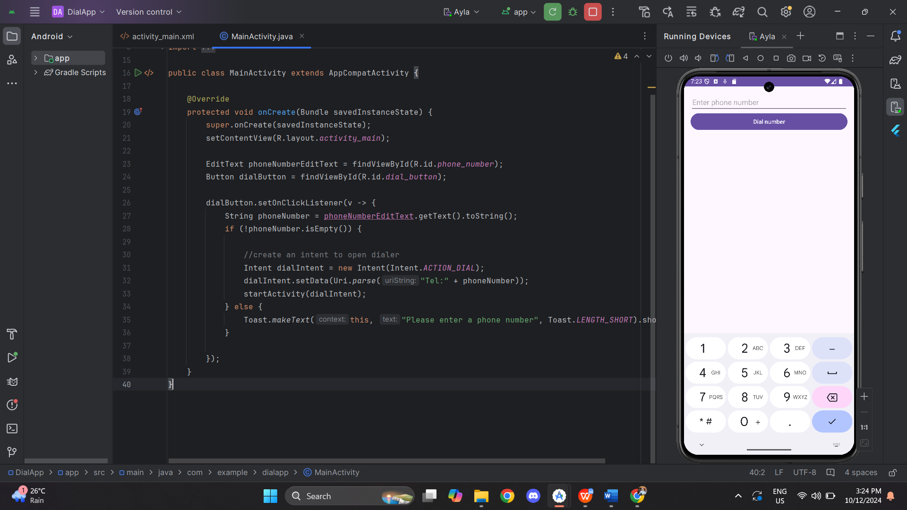 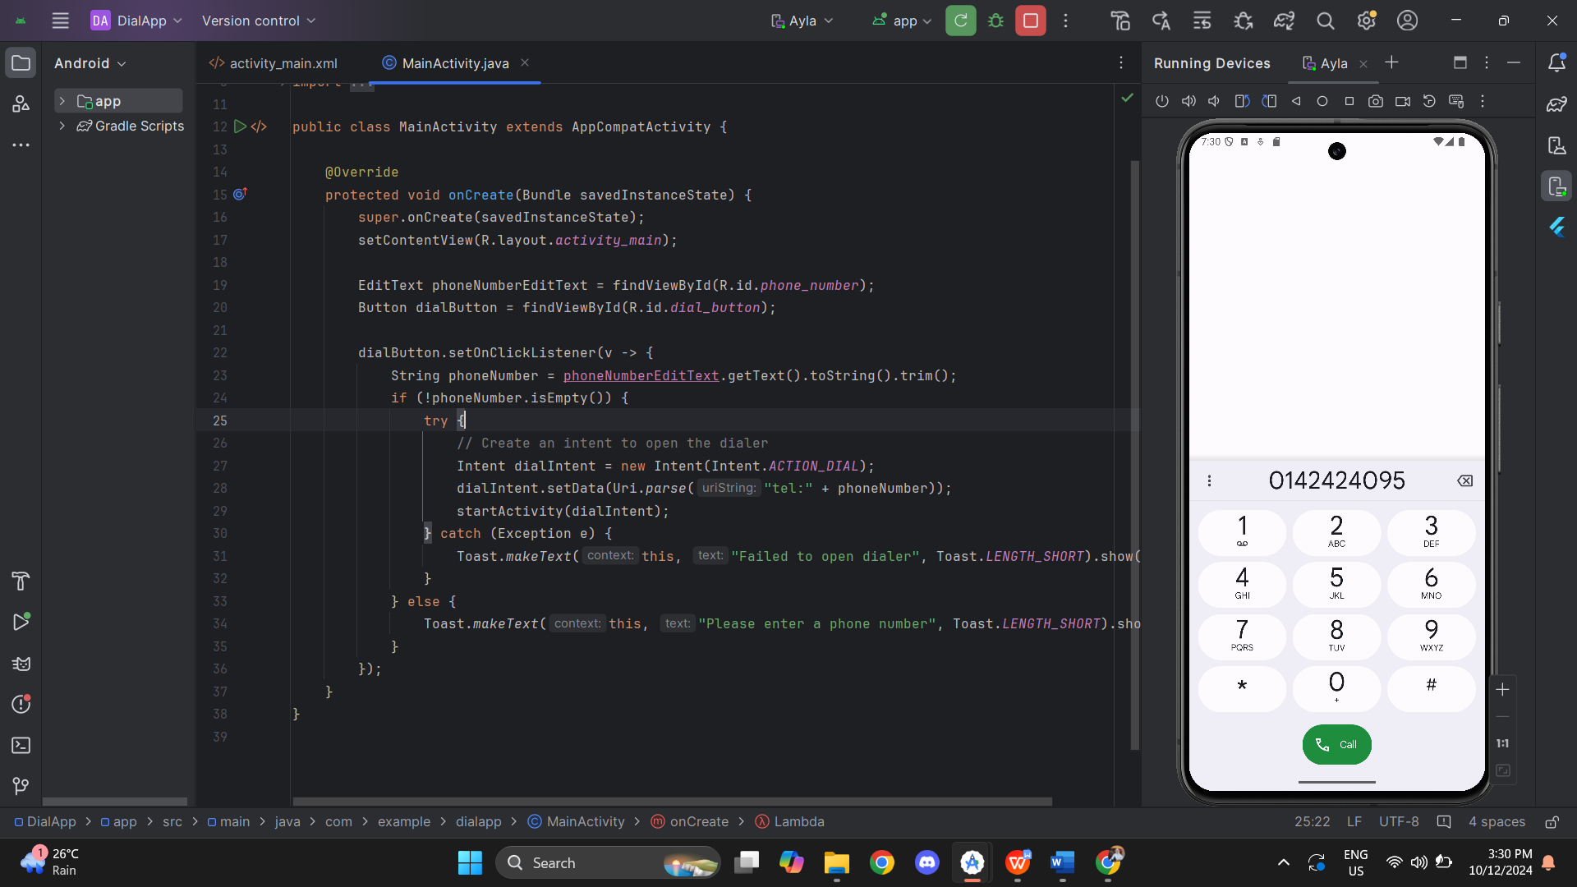 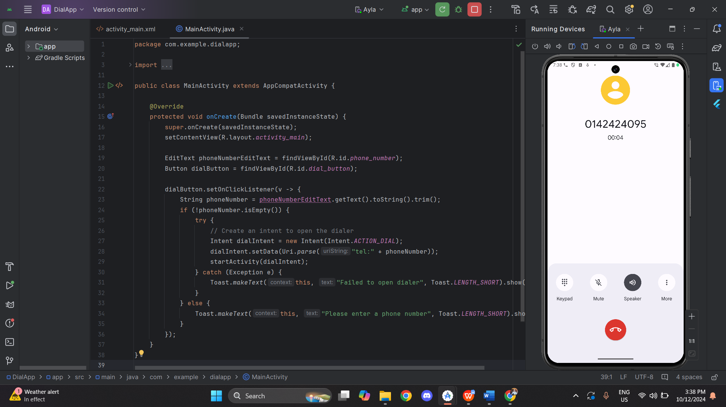

**Activity 2 – Using ACTION_CALL**

MainActivity.java

|  |
| --- |
| package com.example.callapp;  import android.Manifest; import android.content.Intent; import android.content.pm.PackageManager; import android.net.Uri; import android.os.Bundle; import android.widget.Button; import android.widget.EditText; import android.widget.Toast;  import androidx.annotation.NonNull; import androidx.appcompat.app.AppCompatActivity; import androidx.core.app.ActivityCompat;  public class MainActivity extends AppCompatActivity {   private static final int *REQUEST_CALL_PERMISSION* = 1; // Define permission request code   @Override  protected void onCreate(Bundle savedInstanceState) {  super.onCreate(savedInstanceState);  setContentView(R.layout.*activity_main*);   EditText phoneNumberEditText = findViewById(R.id.*phone_number*);  Button callButton = findViewById(R.id.*call_button*);   callButton.setOnClickListener(v -> {  String phoneNumber = phoneNumberEditText.getText().toString();  if (!phoneNumber.isEmpty()) {  makePhoneCall(phoneNumber);  } else {  Toast.*makeText*(this, "Please enter a phone number", Toast.*LENGTH_SHORT*).show();  }  });  }   private void makePhoneCall(String phoneNumber) {  if (ActivityCompat.*checkSelfPermission*(this, Manifest.permission.*CALL_PHONE*) != PackageManager.*PERMISSION_GRANTED*) {  // Request the CALL_PHONE permission  ActivityCompat.*requestPermissions*(this, new String[]{Manifest.permission.*CALL_PHONE*}, *REQUEST_CALL_PERMISSION*);  } else {  // Make the phone call  Intent callIntent = new Intent(Intent.*ACTION_CALL*);  callIntent.setData(Uri.*parse*("tel:" + phoneNumber)); // Corrected "tel:" format  startActivity(callIntent);  }  }   @Override  public void onRequestPermissionsResult(int requestCode, @NonNull String[] permissions, @NonNull int[] grantResults) {  if (requestCode == *REQUEST_CALL_PERMISSION*) {  if (grantResults.length > 0 && grantResults[0] == PackageManager.*PERMISSION_GRANTED*) {  Toast.*makeText*(this, "Permission granted. Try again.", Toast.*LENGTH_SHORT*).show();  } else {  Toast.*makeText*(this, "Permission denied", Toast.*LENGTH_SHORT*).show();  }  }  } } |

Activity_main.xml

|  |
| --- |
| <LinearLayout  xmlns:android="http://schemas.android.com/apk/res/android"  android:layout_height="match_parent"  android:layout_width="match_parent"  android:orientation="vertical"  android:padding="16dp">   <EditText  android:id="@+id/phone_number"  android:layout_width="match_parent"  android:layout_height="wrap_content"  android:hint="Enter phone number"  android:inputType="phone"/>   <Button  android:id="@+id/call_button"  android:layout_width="match_parent"  android:layout_height="wrap_content"  android:text="Make call"/>  </LinearLayout> |

AndroidManifest.xml

|  |
| --- |
| <?xml version="1.0" encoding="utf-8"?> <manifest xmlns:android="http://schemas.android.com/apk/res/android"  xmlns:tools="http://schemas.android.com/tools">  <uses-permission android:name="android.permission.CALL_PHONE" />  <application  android:allowBackup="true"  android:dataExtractionRules="@xml/data_extraction_rules"  android:fullBackupContent="@xml/backup_rules"  android:icon="@mipmap/ic_launcher"  android:label="@string/app_name"  android:roundIcon="@mipmap/ic_launcher_round"  android:supportsRtl="true"  android:theme="@style/Theme.CallApp"  tools:targetApi="31">   <activity  android:name=".MainActivity"  android:exported="true">  <intent-filter>  <action android:name="android.intent.action.MAIN" />   <category android:name="android.intent.category.LAUNCHER" />  </intent-filter>  </activity>  </application>  </manifest> |

Output:

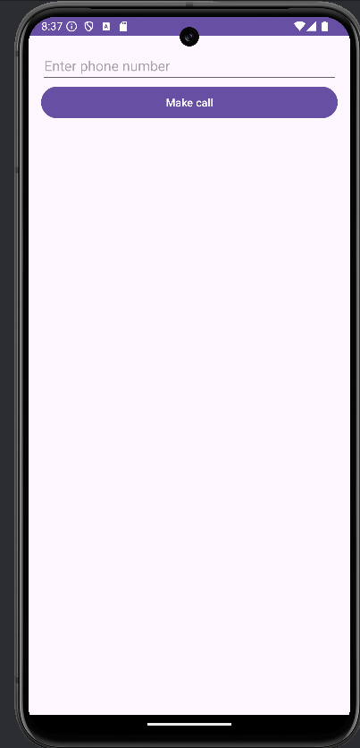 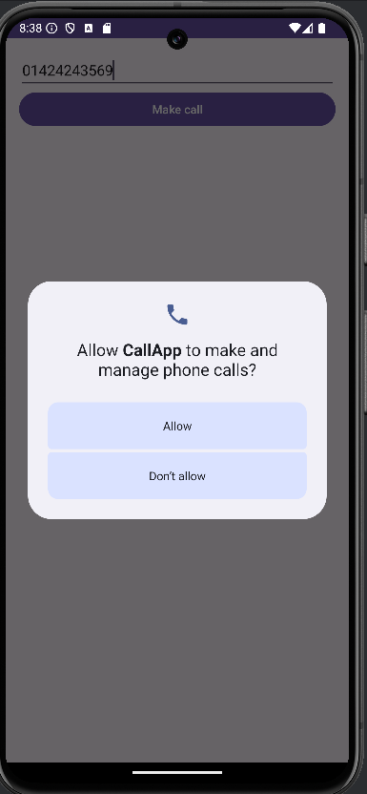 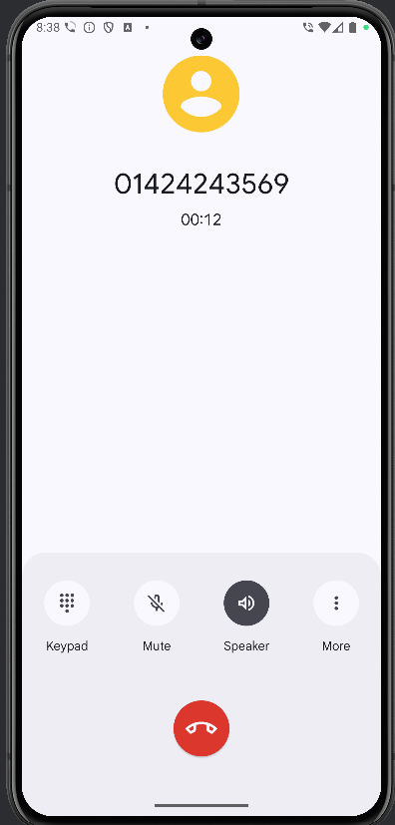

**Activity 3 – ACTION_SENDTO**

MainActivity.java

|  |
| --- |
| package com.example.smsapp;  import android.content.Intent;  import android.net.Uri;  import android.os.Bundle;  import android.widget.Button;  import android.widget.EditText;  import android.widget.Toast;  import androidx.appcompat.app.AppCompatActivity;  public class MainActivity extends AppCompatActivity {  @Override  protected void onCreate(Bundle savedInstanceState) {  super.onCreate(savedInstanceState);  setContentView(R.layout.activity_main);  EditText phoneNumberEditText = findViewById(R.id.phone_number);  EditText messageEditText = findViewById(R.id.message_text);  Button sendButton = findViewById(R.id.send_button);  sendButton.setOnClickListener(v -> {  String phoneNumber = phoneNumberEditText.getText().toString();  String message = messageEditText.getText().toString();  if (!phoneNumber.isEmpty() && !message.isEmpty()) {  // Use ACTION_SENDTO intent to send SMS  Intent smsIntent = new Intent(Intent.ACTION_SENDTO);  smsIntent.setData(Uri.parse("smsto:" + phoneNumber)); // Set the SMS URI  smsIntent.putExtra("sms_body", message); // Set the SMS message body  try {  startActivity(smsIntent);  } catch (Exception e) {  Toast.makeText(this, "Failed to send SMS", Toast.LENGTH_SHORT).show();  }  } else {  Toast.makeText(this, "Please enter a phone number and message", Toast.LENGTH_SHORT).show();  }  });  }  } |

Activity_Main.xml

|  |
| --- |
| <LinearLayout  xmlns:android="http://schemas.android.com/apk/res/android"  android:layout_width="match_parent"  android:layout_height="match_parent"  android:orientation="vertical"  android:padding="16dp">  <EditText  android:id="@+id/phone_number"  android:layout_width="match_parent"  android:layout_height="wrap_content"  android:hint="Enter a phone number"  android:inputType="phone"/>  <EditText  android:id="@+id/message_text"  android:layout_width="match_parent"  android:layout_height="wrap_content"  android:hint="message"  android:inputType="textMultiLine"/>  <Button  android:id="@+id/send_button"  android:layout_width="match_parent"  android:layout_height="wrap_content"  android:text="Send SMS"/>  </LinearLayout> |

Output:

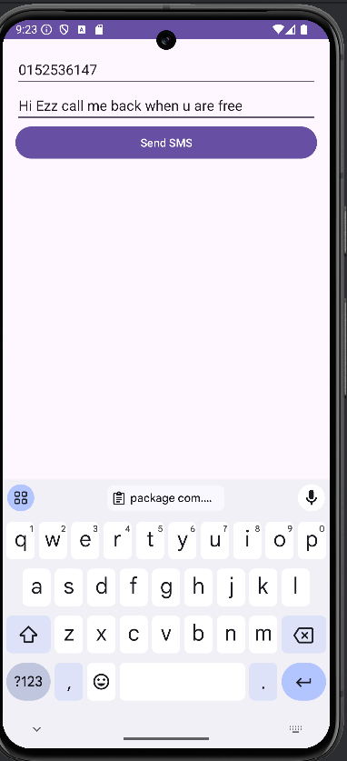 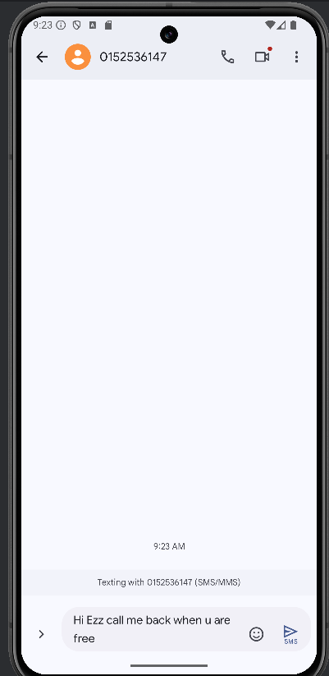 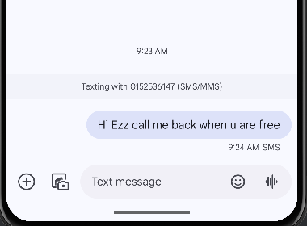

**Activity 4 – Using SMSManager**

MainActivity.java

|  |
| --- |
| package com.example.smsmanagerapp;  import android.Manifest;  import android.content.pm.PackageManager;  import android.os.Bundle;  import android.telephony.SmsManager;  import android.widget.Button;  import android.widget.EditText;  import android.widget.Toast;  import androidx.annotation.NonNull;  import androidx.appcompat.app.AppCompatActivity;  import androidx.core.app.ActivityCompat;  public class MainActivity extends AppCompatActivity {  private static final int REQUEST_SMS_PERMISSION = 101;  @Override  protected void onCreate(Bundle savedInstanceState) {  super.onCreate(savedInstanceState);  setContentView(R.layout.activity_main);  EditText phoneNumberEditText = findViewById(R.id.phone_number);  EditText messageEditText = findViewById(R.id.message_text);  Button sendButton = findViewById(R.id.send_button);  sendButton.setOnClickListener(v -> {  String phoneNumber = phoneNumberEditText.getText().toString();  String message = messageEditText.getText().toString();  if (!phoneNumber.isEmpty() && !message.isEmpty()) {  if (ActivityCompat.checkSelfPermission(this, Manifest.permission.SEND_SMS) != PackageManager.PERMISSION_GRANTED) {  ActivityCompat.requestPermissions(this, new String[]{Manifest.permission.SEND_SMS}, REQUEST_SMS_PERMISSION);  } else {  sendSMS(phoneNumber, message);  }  } else {  Toast.makeText(this, "Please enter both phone number and message", Toast.LENGTH_SHORT).show();  }  });  }  private void sendSMS(String phoneNumber, String message) {  try {  SmsManager smsManager = SmsManager.getDefault();  smsManager.sendTextMessage(phoneNumber, null, message, null, null);  Toast.makeText(this, "SMS sent successfully", Toast.LENGTH_SHORT).show();  } catch (Exception e) {  Toast.makeText(this, "Failed to send SMS: " + e.getMessage(), Toast.LENGTH_SHORT).show();  }  }  @Override  public void onRequestPermissionsResult(int requestCode, @NonNull String[] permissions, @NonNull int[] grantResults) {  super.onRequestPermissionsResult(requestCode, permissions, grantResults); // Call the superclass method  if (requestCode == REQUEST_SMS_PERMISSION) {  if (grantResults.length > 0 && grantResults[0] == PackageManager.PERMISSION_GRANTED) {  Toast.makeText(this, "Permission granted. Try again.", Toast.LENGTH_SHORT).show();  } else {  Toast.makeText(this, "Permission denied", Toast.LENGTH_SHORT).show();  }  }  }  } |

Activity_main.xml

|  |
| --- |
| <LinearLayout  xmlns:android="http://schemas.android.com/apk/res/android"  android:layout_width="match_parent"  android:layout_height="match_parent"  android:orientation="vertical"  android:padding="16dp">   <EditText  android:id="@+id/phone_number"  android:layout_width="match_parent"  android:layout_height="wrap_content"  android:hint="Enter a phone number"  android:inputType="phone" />   <EditText  android:id="@+id/message_text"  android:layout_width="match_parent"  android:layout_height="wrap_content"  android:hint="Enter your message"  android:inputType="textMultiLine"/>   <Button  android:id="@+id/send_button"  android:layout_width="match_parent"  android:layout_height="wrap_content"  android:text="Send SMS" />  </LinearLayout> |

AndroidManifest.xml

|  |
| --- |
| <?xml version="1.0" encoding="utf-8"?> <manifest xmlns:android="http://schemas.android.com/apk/res/android"  xmlns:tools="http://schemas.android.com/tools">   <uses-permission android:name="android.permission.SEND_SMS"/>  <application  android:allowBackup="true"  android:dataExtractionRules="@xml/data_extraction_rules"  android:fullBackupContent="@xml/backup_rules"  android:icon="@mipmap/ic_launcher"  android:label="@string/app_name"  android:roundIcon="@mipmap/ic_launcher_round"  android:supportsRtl="true"  android:theme="@style/Theme.SMSManagerApp"  tools:targetApi="31">  <activity  android:name=".MainActivity"  android:exported="true">  <intent-filter>  <action android:name="android.intent.action.MAIN" />   <category android:name="android.intent.category.LAUNCHER" />  </intent-filter>  </activity>  </application>  </manifest> |

Output:

